DATA ANALYTICS

ASSIGNMENT 1

Lok-sabha election analysis

TEAM MEMBERS

NAME SRN  
VIMARSHA R PES1201701590

VINUTHA M N PES1201701373

KEERTHI PRIYA P PES1201701643

Recent Lok-sabha election dataset was taken to make analysis on the results and draw conclusions out of it.

# STATE WISE NO-OF-SEATS FOR EACH PARTY

# TOP 5 PARTIES WITH HIGHEST NUMBER OF SEATS

# STATE WISE HIGHEST NUMBER OF SEATS

# STATE WISE TOTAL NUMBER OF VOTES

# TOP 10 CANDIDATES WITH HIGHEST NUMBER OF VOTES

IMPORTING OF DATASET

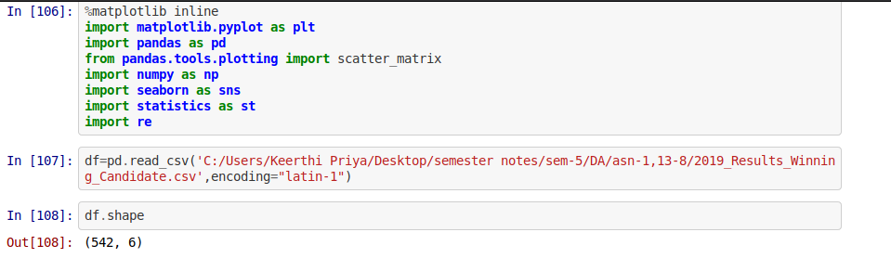

# STATE WISE NO-OF-SEATS FOR EACH PARTY

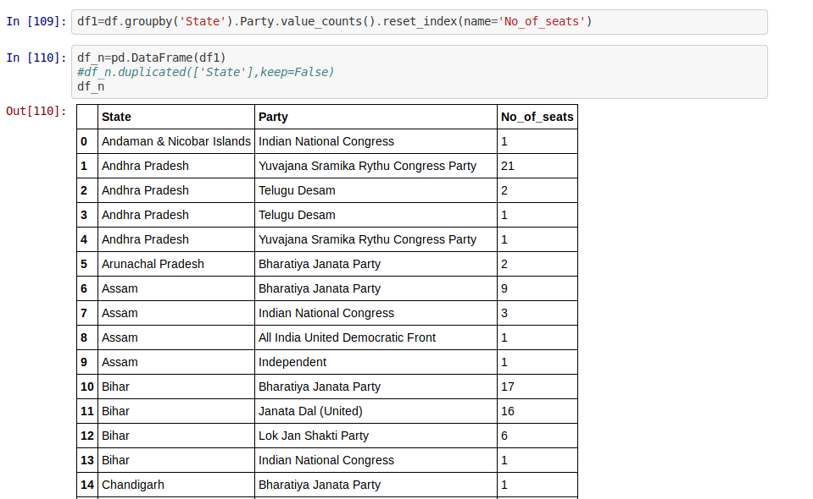

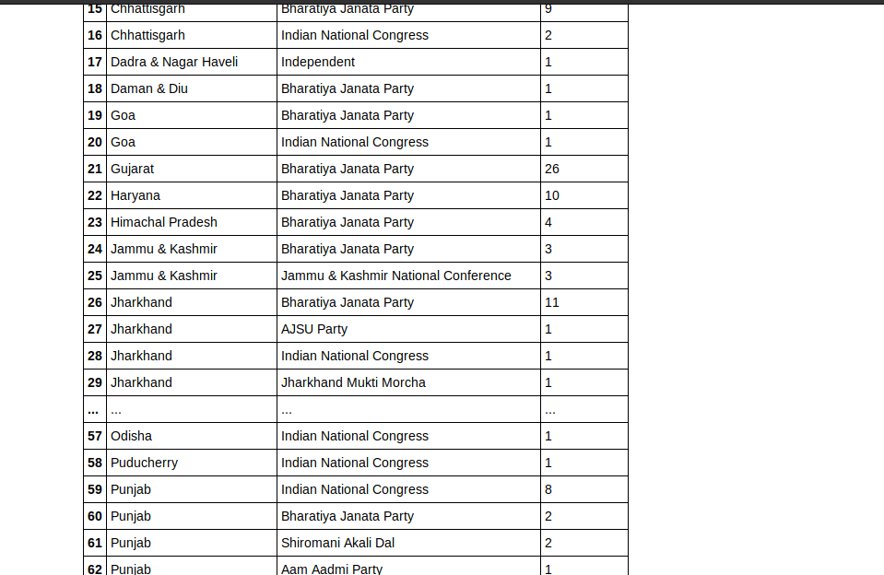

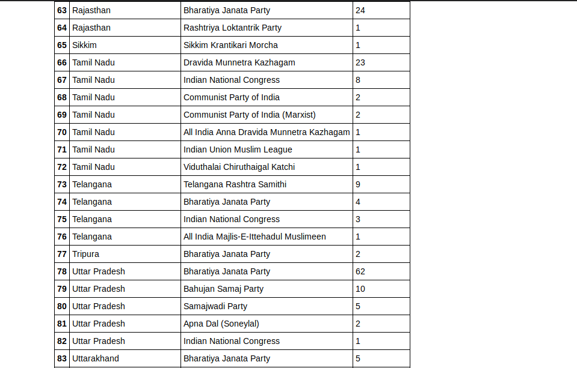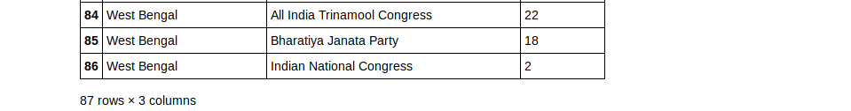

# TOP 5 PARTIES WITH HIGHEST NUMBER OF SEATS

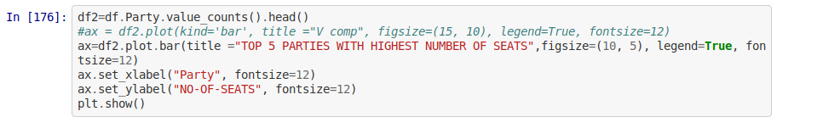

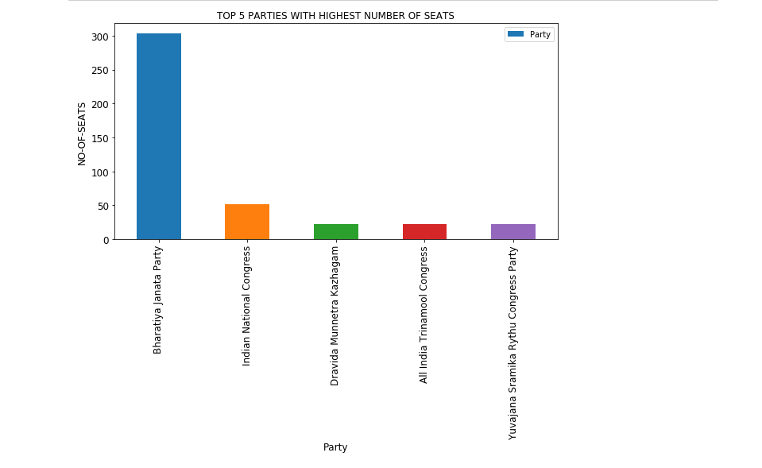

# STATE WISE HIGHEST NUMBER OF SEATS

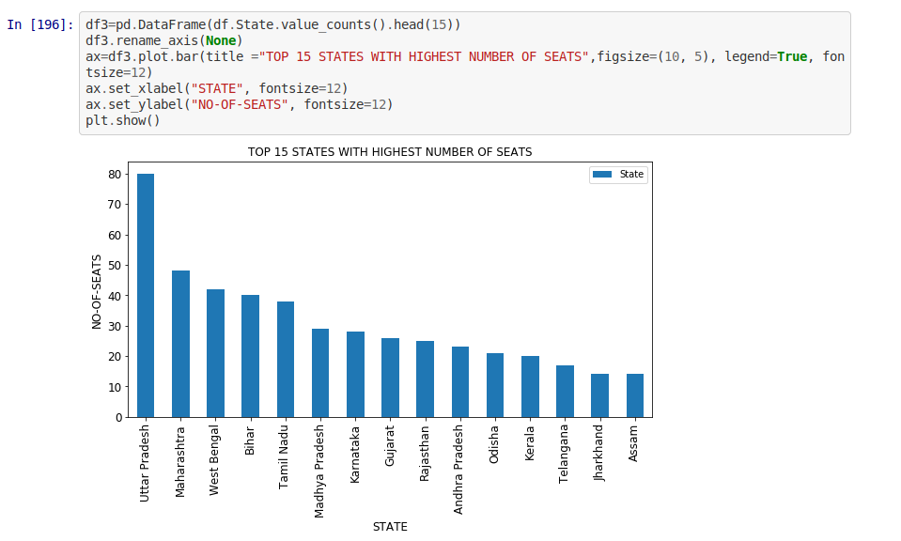

# STATE WISE TOTAL NUMBER OF VOTES

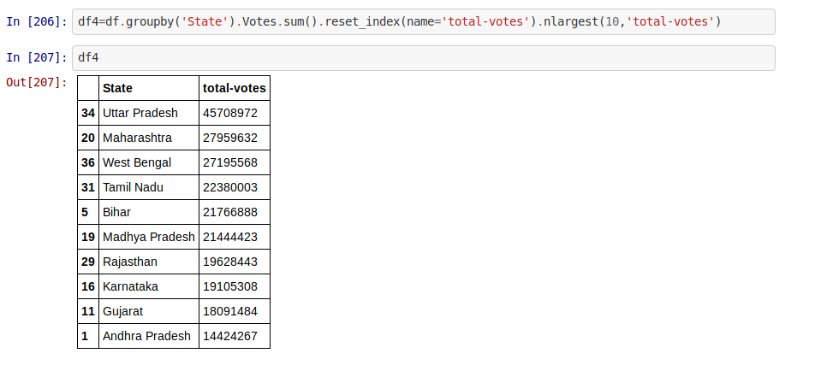

PIE CHART REPRESENTATION OF STATE WISE TOTAL NUMBER OF VOTES

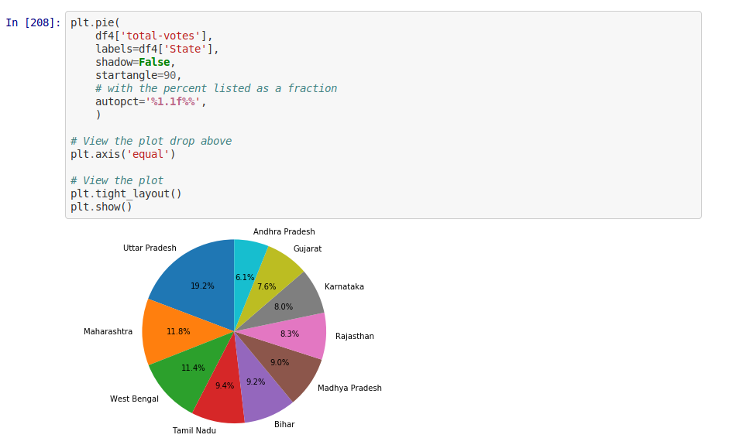

# TOP 10 CANDIDATES WITH HIGHEST NUMBER OF VOTES

